Enter an Electronic Termination

Initiators

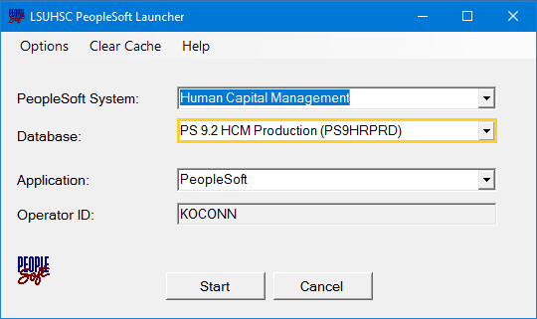
- All tasks for PER 3 - Terminations will be performed in PS HCM Production database.

NOTE: PER 3 – Terminations are used for all
employee types, except Gratis employees. For
Gratis employees, continue to send notification
of separation to distribution list and paper
PER 3.

LSUHSC-NONotificationofEmployeeSeparation@lsuhsc.edu

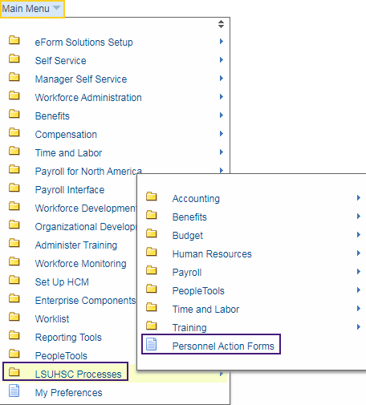
- Click the Main Menu link.

Click LSUHSC Processes, then Personnel Action Forms.

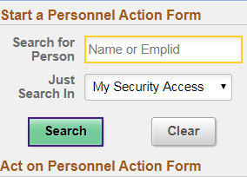
- You can search for an employee by entering his/her last
name or Empl ID.

Enter the desired information into the Search for Person field. Enter a valid value e.g. "Doe".

Click the Search button.

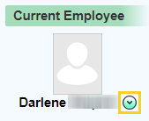
- A list of employees with the first name 'Doe' displays on the right side of the page Scroll down the page until you locate the correct employee. Click the drop-down button next to the employee name to view available actions.

Click the button to the right of the Employee Name field.

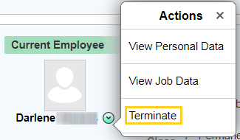
- Click the Terminate button.

NOTE: If an employee is on LWOP, you will not see a
an option to terminate. Please contact HRM with the
date the employee will return from LWOP (effective
date of termination).

- The notes in red explain how to determine the correct effective date, and for the resignation letter or other documentation to be uploaded as appropriate. If someone has taken leave, s/he is still in ‘Active’ status. The first day of ‘Inactive’ status is the day after the last day of active employment.

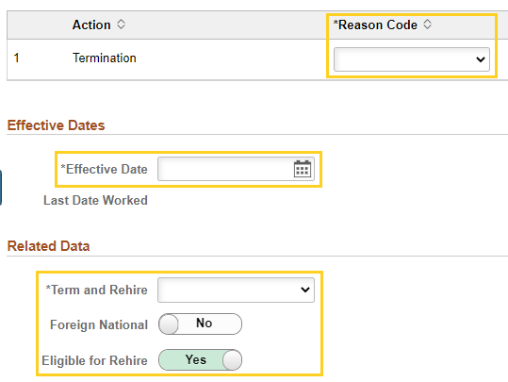
- Once Terminate is selected, a panel will display where you will enter information required for the PeopleSoft termination process.
The Initiator will enter information into the following fields:

Action Termination Reason Code
    - Effective Date
    - Term and Rehire
    - Foreign National (Yes or No)
    - Eligible for Rehire (Yes or No)

- Click the button to the right of the
Reason Code field.

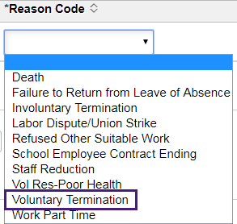
- Reason Codes correlate with the Department of
Labor separation notices,
Most Common:
- Voluntary Termination
- Involuntary Termination – use in case of issuance
of non-renewal notice
- School Employee Contract Ending – use in case of’
End of appointment/student graduating

Click the Voluntary Termination list item.

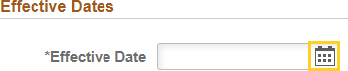
- Click the Calendar button.

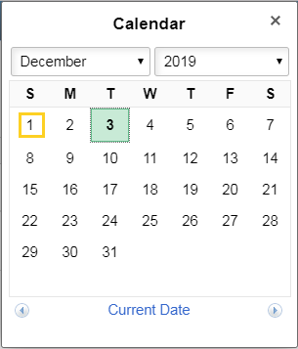
- Click the desired date.

- The Term and Rehire field is used if an employee
is moving between positions within LSUHSC with
no break in service. When this occurs, the employee
must be terminated from one position within LSUHSC
and re-hired to the new position. If this is the case,
follow the steps below:

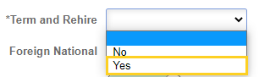
Click the drop-down button for the Term and
Rehire field. Select the Yes option. When selecting
‘Yes’, please put notes in the Reason/Justification
box to advise the new position the employee is
moving to and confirm “no break in service.”

This is important so that the Talent Acquisition/
Operations Team is able to manage the termination/
hire in PeopleSoft to ensure the Employee’s access
is not interrupted – such as ID badge function,
Parking access, email access, etc.

- Click the Foreign National radio button to
select ‘Yes’ the employee is a Foreign
National. This will ensure the termination
routes through the International Services
Office.

- Only click the radio button to select the ‘No’
option for Eligible for Rehire if you have
been advised by Employee Relations to
make this selection.

- If an employee is moving to another position,
with no break in service, please add notes to
the Reason/Justification section indicating
as much. This is so HRM can coordinate the
termination and rehire for the same day to
avoid access interruption. The Department
must submit timely documents for the new
position to HRM for PeopleSoft entry.

- Add File Attachment.

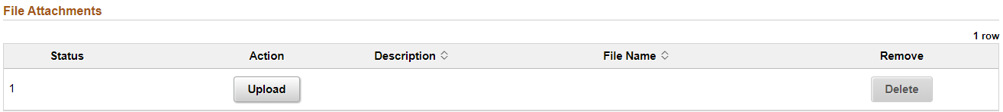

File Attachments are required for all terminations except: Fellows, Interns, Student Workers, Graduate Assistants, and House Officers. If supporting documents are not required, please provide justification in the Reason/Justification box (e.g., Student Worker/Graduate Assistant graduated or end of appointment). A Description for an uploaded file is required.

The following options are available if you are an Initiator:

- If you are not ready to submit the termination,
click the Save button. This will allow you to
return at a later time to complete the form. No
one will have access to the saved action except
yourself.

- Click the Update Personnel Action Form button to recall
saved pending terminations, when you are ready to
continue/complete.

- Click the Submit button.

NOTE: For terminations submitted/processed through the
electronic termination system, notification of separation to the
distribution list is sent automatically once the termination is complete.

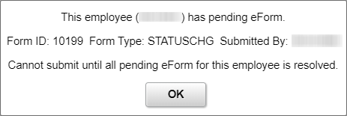
- If a termination has previously been initiated
and a new one begun, an error message will
be received when the new termination is
Submitted.

- The Initiator must cancel the duplicate
transaction and submit the original.

Click the Withdraw button to cancel the duplicate
transaction.

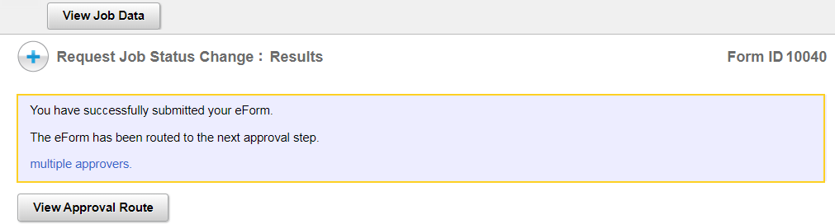
- The Initiator will receive a confirmation message after clicking the Submit button.

- The Initiator will click the View Personnel Action Form button to view the status of the termination once it enters the approval process.

After searching for the terminated employee:
Click the NEXT button at the bottom of the page,
and then click the View Approval Route button.

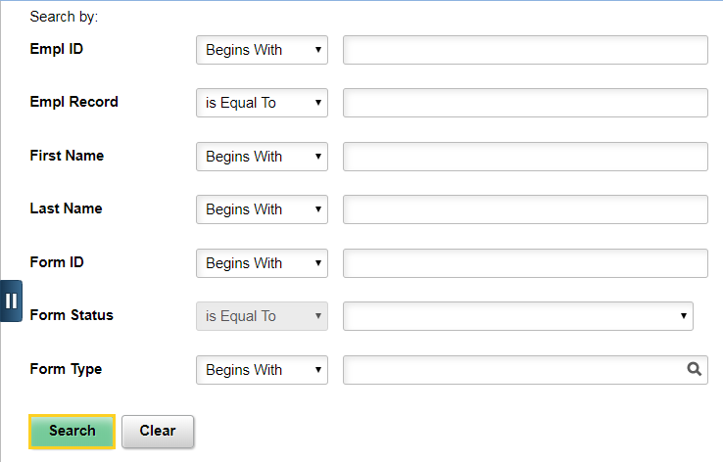
- NOTE: The Initiator can search by any of the
various methods displayed, but can also
simply click the Search button to either go directly to the next panel, or to get a list of Search result options at the bottom of the
page. This option will be used for example
when making adjustments requested by the Approver to the termination.

Approvers

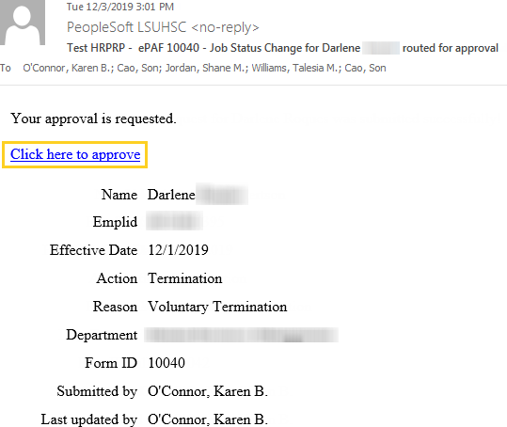
- The next level Approver will receive an email request to approve the transaction. The Approver will click the link in the email notification to navigate to the approval panel.

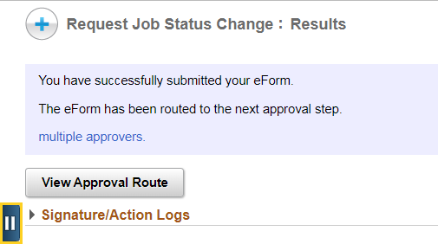
- The Request Job Status Change: Results
confirmation message displays.
Click the Open Sidebar Menu button.

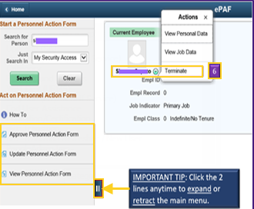
- You have three actions from which to choose
on the sidebar menu:

Approve Personnel Action Form – used

to approve pending terminations in

your queue
- Update Personnel Action Form – used
to recall saved/pending terminations you
are ready to continue/complete.
- View Personnel Action Form – used
to view the status of the termination in
the approval process

- Approvers have two options for navigating to approve a Termination:

Use the email link from the Job Status Change email, or
- Approve Personnel Action Form

- The Update Personnel Action Form option is where the forms go for which the Approver clicked Recycle (with or without comments).

Recycled forms can be modified and sent back to the Approver.

- Click the Approve Personnel Action Form button.

- The Approver can search by any of the
various methods displayed, but can also
simply click the Search button to either go directly to the next panel, or to get a list of Search result options at the bottom of the
page.

Click the Search button.

- Click the Pending - Darlene link.

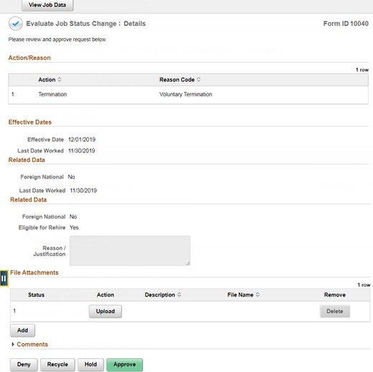
- The Evaluate Job Status Change: Details panel displays.

Click the Open Sidebar Menu button.

- The same basic process is used when selecting the Update
Personnel Action Form as choosing Approve Personnel
Action Form. However, the Initiator is able to make
updates to the form until the form is fully approved. In
doing so, approval workflow will reset back to the first
approval step.

Click the Update Personnel Action Form button.

- Click the Search button.

- Click the Pending - Darlene link.

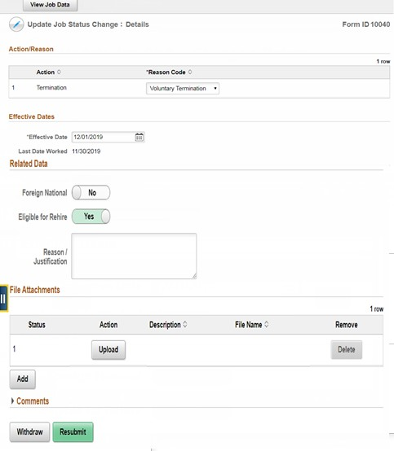
- The Update Job Status Change: Details panel displays.
Click the Open Sidebar Menu button.

- The same basic process is used when selecting the View Personnel Action Form as choosing Approve Personnel Action Form. However, this is a record keeping panel.

Clicking the Search button brings up a history of all transactions the Initiator processed.
Click the View Personnel Action Form button.

- Click the Search button.

- Click the Pending - Darlene link.

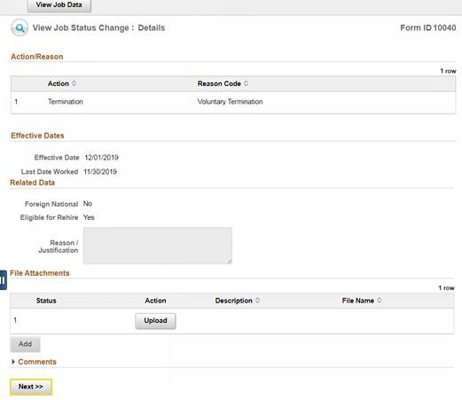
- The View Job Status Change: Details panel displays.
Click the Next button.

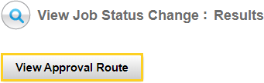
- Clicking the View Approval Route will display the next step Approvers in the termination process.

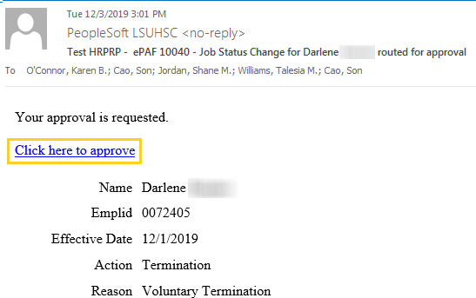
- Clicking the link provided in the Job Status Change email brings the Approver to a panel where s/he is able to view the information entered for the transaction and then approve.

Click the ‘Click here to approve’ link.

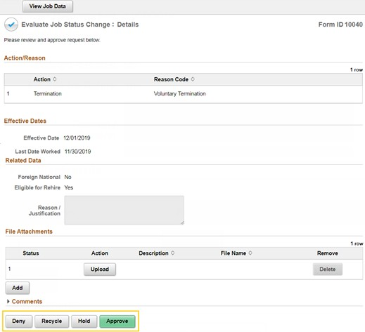
- The Evaluate Job Status Change: Details panel displays.

- The Approver has four options from which to choose:

Approve – will move termination to next

level of approval
  - Hold – allows approver to return to review/
approve at a later date
  - Recycle – additional information/documentation
Is required. This will send the termination back to the Initiator to correct and resubmit for approval. Add comments in Comments box if “recycling” the termination request to indicate why it is being recycled. (e.g., incorrect effective date/no supporting document attached)
  - Deny – cancel termination

The Approve option will be demonstrated and each of the other options discussed.

- Click the Approve button.

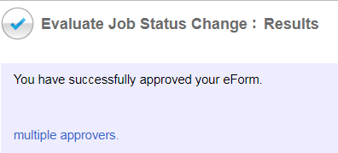
- A confirmation message will display after the Approve button is clicked.

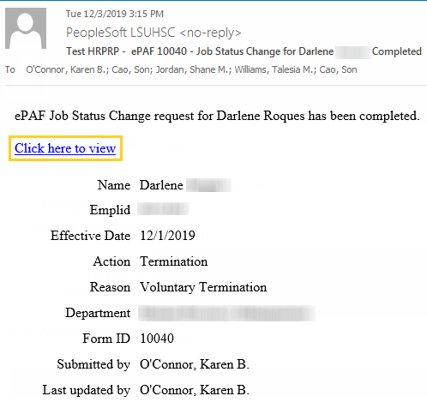
- The Approver will receive a Job Status Change email confirming the Termination has been approved. Select the ‘Click here to view’ link to navigate to the View Job Status Change: Details panel.

- Clicking 'Recycle' will send the form back to the Initiator. The Approver has the ability to add comments relative to what information has to be modified. Typically, this is done when date changes have to made, because the Approver is not able to make changes to the information submitted by the Initiator.

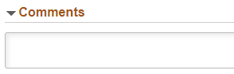
Please add comments in the Comments box when Recycling
the Termination request to indicate why it is being recycled
(e.g., Incorrect effective date, no supporting documentation
Attached).

If a termination is recycled, it will go back to the Initiator
to correct and resubmit for approvals.

- Clicking 'Deny' will cancel the transaction, which cannot be undone by the Initiator. This would not be done if modifications have to be made, but rather when the employee, or his/her manager, has decided not to move forward with the termination.

- Clicking 'Hold' is similar to clicking Save, where the form still exists, and the Initiator can make modifications, but the termination is not going to occur at that time for various reasons.

- Shown are the 3 different emails (outside of Approve) the Initiator will receive depending on if the Approver chose to Recycle, Deny, or Hold the transaction.

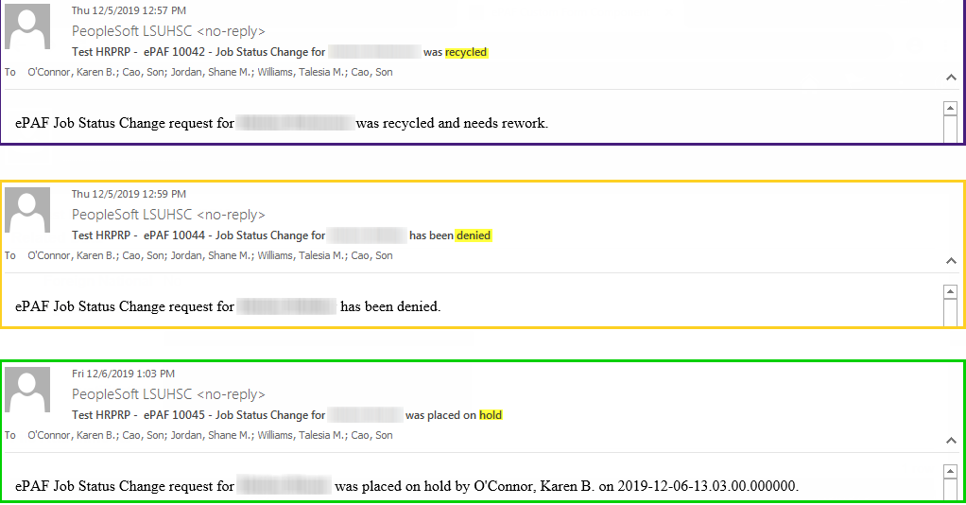

Items to Note
- The Effective Date cannot be before an effective dated row. If an employee’s termination is processed on 10/1, but backdated to 9/1, then the transaction will be allowed as long as the previous effected dated row is not 8/31 or after. So, if an employee has an effective dated row of 9/15, with any type of change (pay rate, transfer, title change, etc.), then the termination transaction would not be backdated prior to 9/16.

- The error shown below will display upon clicking ‘Submit’. The Initiator then has to look at the last effective dated row in PeopleSoft and contact HR Operations to have the change made.

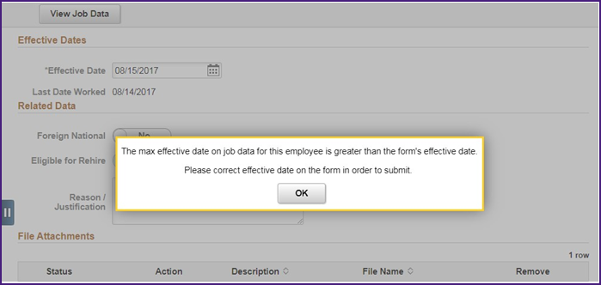

- Once the Approver clicks ‘Submit’, the transaction is sent to HR Operations for final submission. No changes can be made to the form once it is fully approved.

- The Initiator can verify the transaction in Job Data.
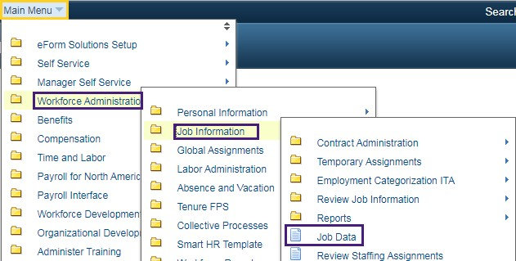
Click the Main Menu link.

Click the Workforce
Administration link.

Click the Job Information link.

Click the Job Data link.

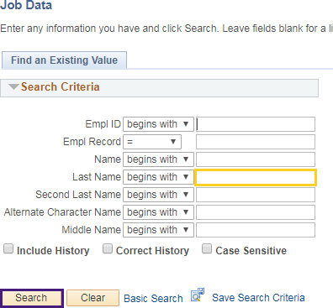
- Enter the desired information into the Last Name field. Enter a valid value e.g. "Doe". Click the Search button.

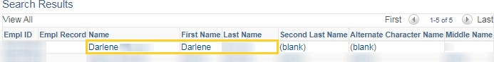
- Click the Doe link.

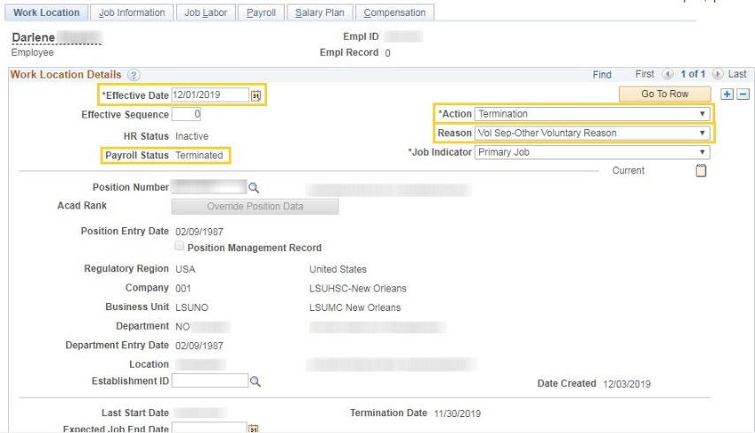
- The employee Job Data record is updated once HR Operations submits the transaction. (HR Operations controls the final submission because transactions cannot be submitted while payroll is processing.

- This completes Enter an Electronic Terminations.

End of Procedure.

