PER-3
Additional Compensation

Version Date: October 29, 2018

Table of Contents
PER-3 Additional Compensation 1
Enter a PER-3 Requisition 1
Clone a PER-3 Requisition 22
Review a Saved Draft 34

PER-3 Additional Compensation

Enter a PER-3 Requisition
Procedure

In this topic you will learn how to Enter a PER-3 Requisition.

Step | Action
 | Occasionally, there will be circumstances when PER-3s will not fit in this workflow model. In these cases, paper PER-3s should be submitted on paper. The largest type of these exceptions is the 'supersede', which will continue to be submitted on pink paper.
 | In this exercise, you will enter a PER-3 requisition for an employee serving as the acting chair for a department for Fiscal Year 2019. The employee will receive a regular supplement of $18,000 for the year.

Step | Action
 | Click the Main Menu link.
 | Click the LSUHSC Processes link.
 | Click the Human Resources link.
 | Click the Use link.
 | Click the Create PER-3 Requisition link.

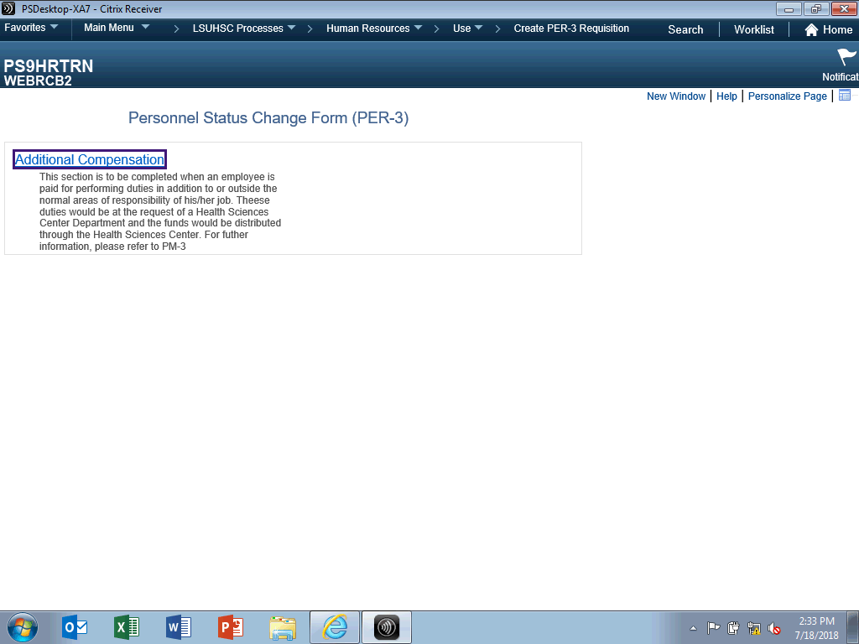

Step | Action
 | Click the Additional Compensation link.

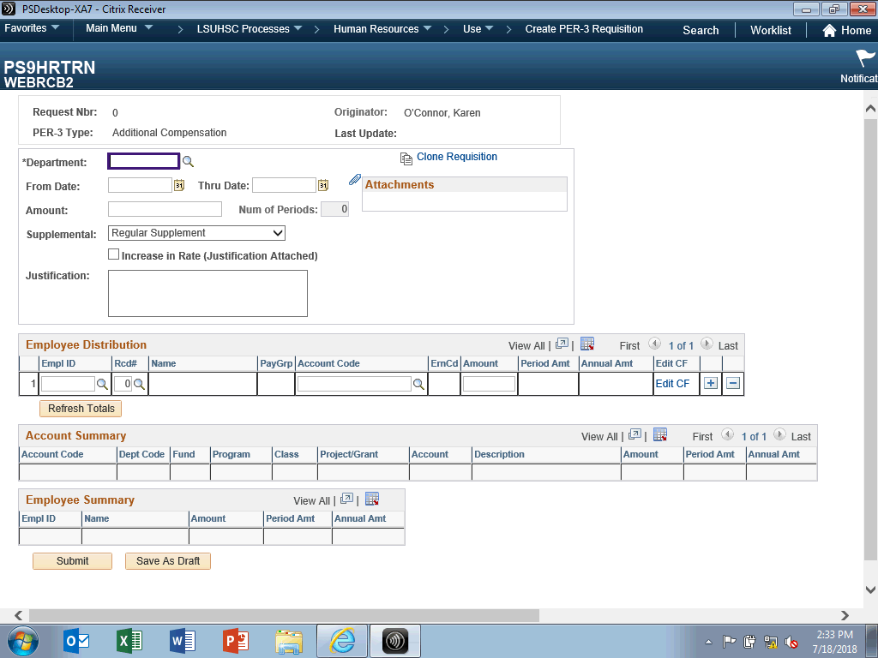

Step | Action
The Department will be used to determine routing for approvals. The Business Unit designation 'NO' must be enter in front of the seven-digit department number. If you do not know your Department number, you can search for using the Look up Department button to the right of the Department field.

Enter the desired information into the Department field. Enter "NO1494000".

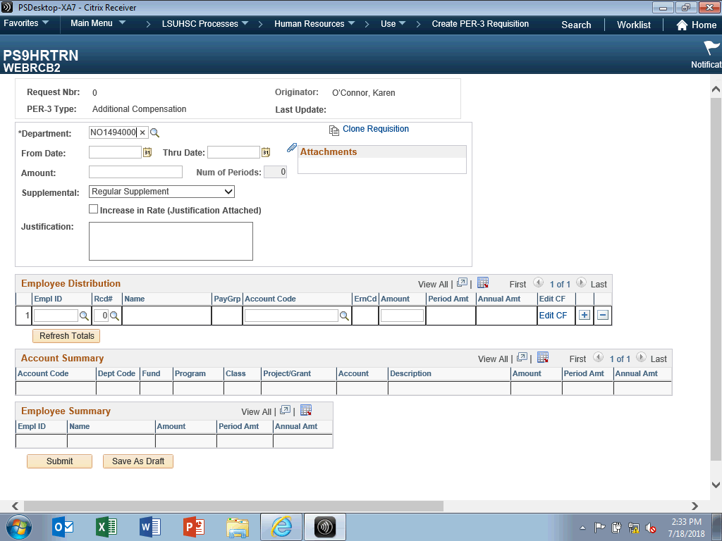

Step | Action
From and Thru Dates

• From Date cannot be older than 180 days (~ 6 months) from today.
• Thru Date cannot be later than 365 days from today.
• From/Thru Dates cannot cross Fiscal Years.

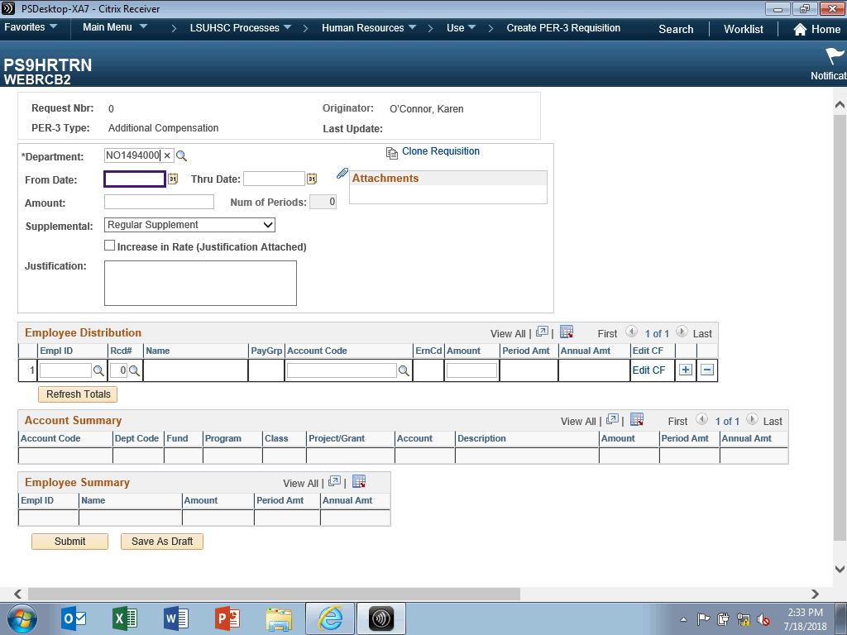

Step | Action
The From Date can only start on the first day of the month.

Enter the desired information into the From Date field. Enter "07012018".

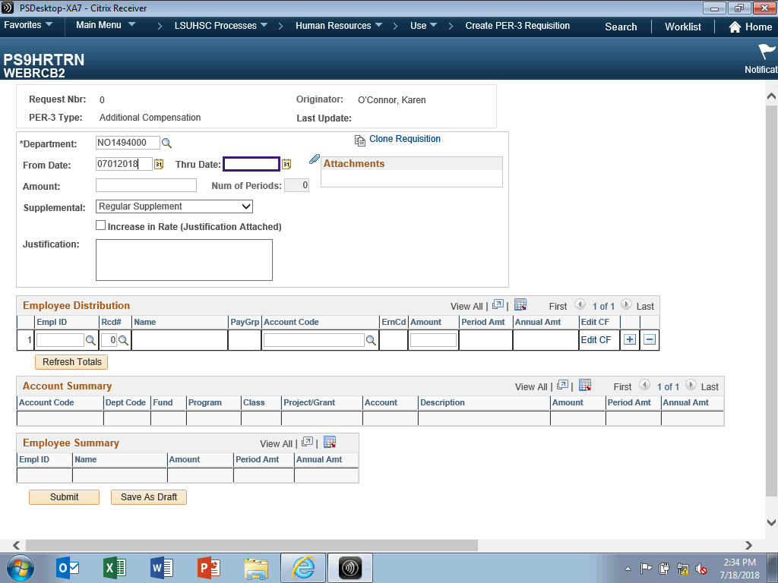

Step | Action
The Thru Date can only end on the last day of the month, unless the period is less than one month.
Enter the desired information into the Thru Date field. Enter "06302019".

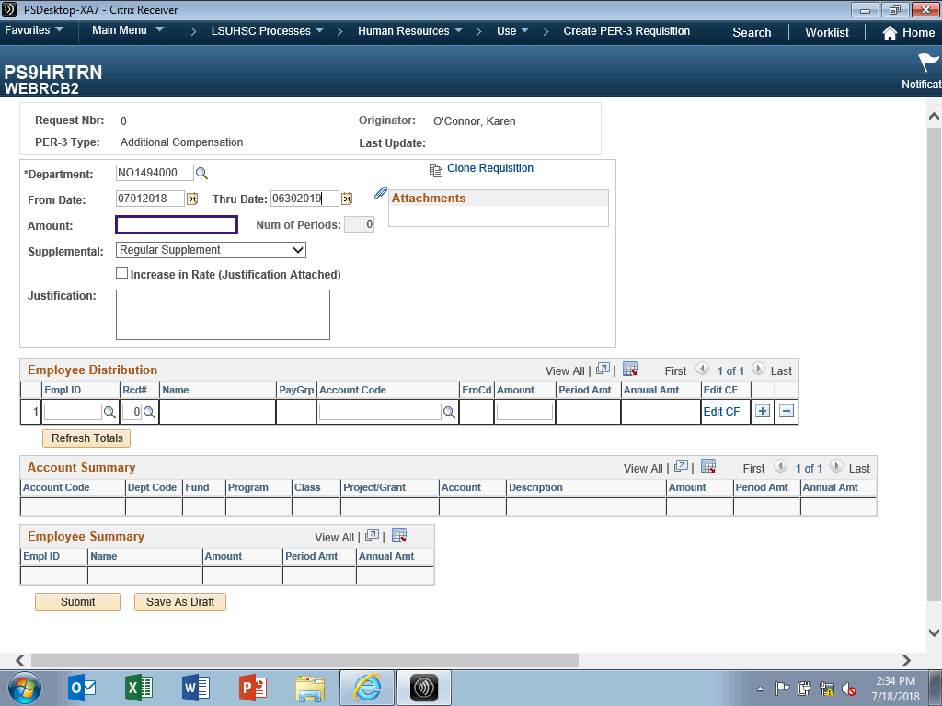

Step | Action
The Amount entered will be the total amount for the indicated period. As previously stated for this exercise, $18,000 will be entered for Fiscal Year 2019.

Enter the desired information into the Amount field. Enter "18000.00".

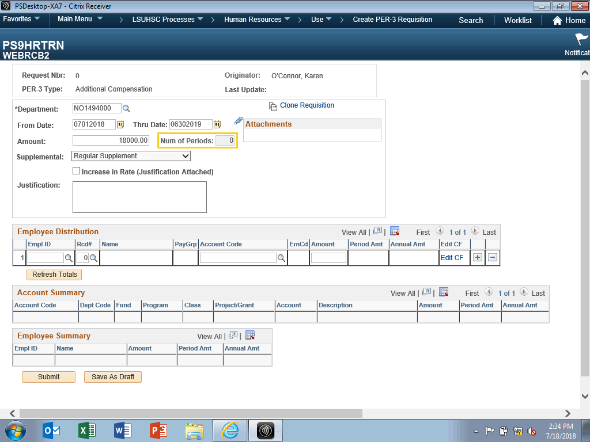

Step | Action
 | NOTE: Num of Periods defaults to zero and will remain zero until the Refresh Totals button is clicked later in the exercise. Once refreshed, the Num of Periods will display the number of pay periods the funds will be distributed over based on the From/Thru Dates.

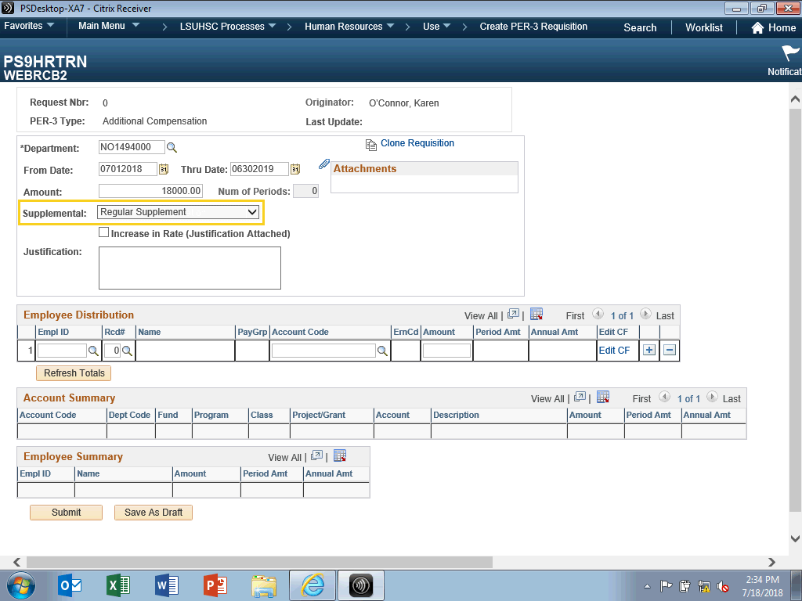

Step | Action
Supplemental compensation is rendered to an employee for performing work outside the scope of his/her normal duties. There are two options available under Supplemental:
• Regular Supplemental - Used for additional compensation that is non clinical, i.e, administrative faculty with department chair duties.
• Additional Compensation - Types of additional compensation may include such payments as one-time pay, faculty income plan (FIP) compensation, or supplemental compensation. i.e. patient care related.

NOTE: For this exercise, Supplemental will remain as Regular Supplement.

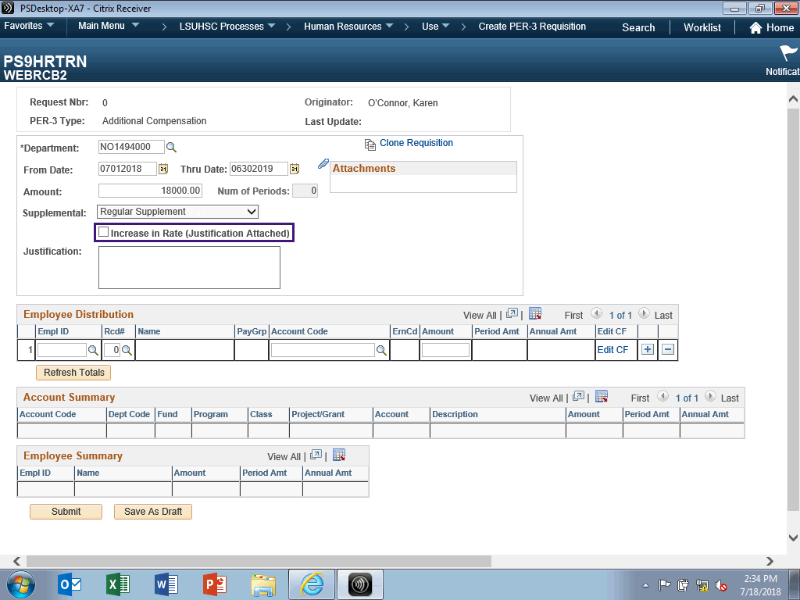

Step | Action
When doing an increase in rate, you must include in your justification when the rate increase will be used (i.e., regular supplement or additional compensation) and why the increase is merited.

Click the Increase in Rate (Justification Attached) option.

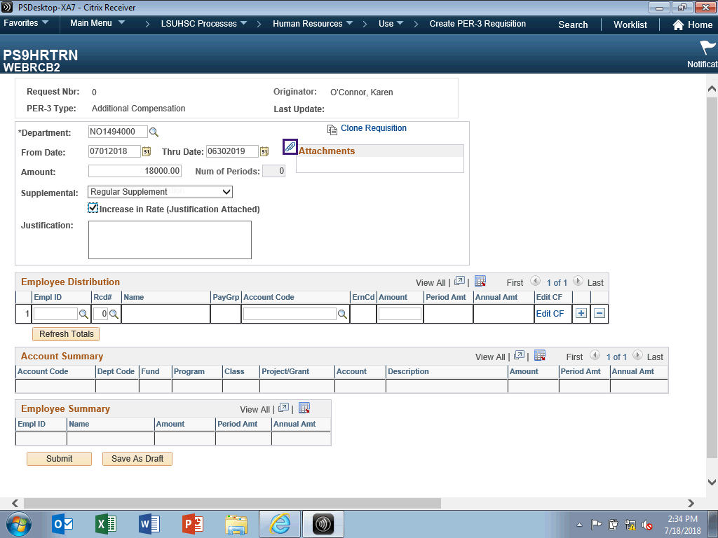

Step | Action
Click the Add Attachment button.

NOTE: Social Security Numbers should not be included in attachments.
 | Click the Browse button.
 | Click the PER-3 Justification link.
 | Click the Open button.
 | Click the Upload button.

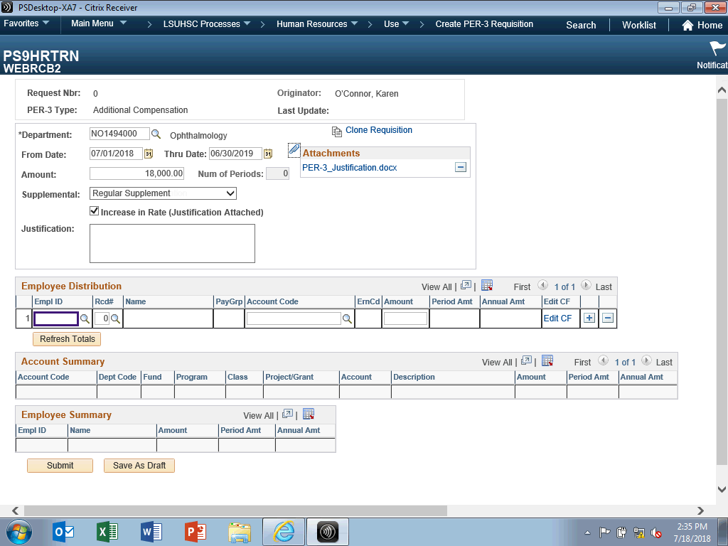

Step | Action
 | Enter the desired information into the Empl ID field. Enter "0137137".

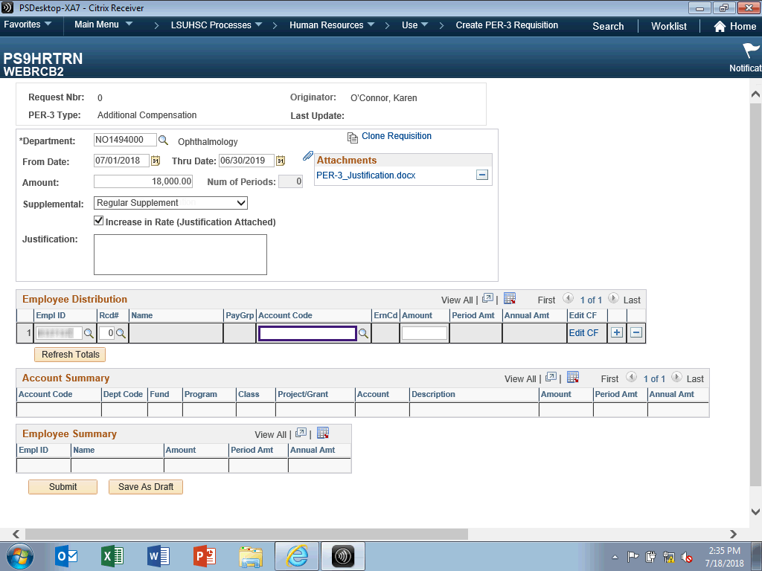

Step | Action
NOTE: Only use Account Codes 501300, 501310, 501315, 501340, and 505300.

Enter the desired information into the Account Code field. Enter "14976029FA-501310".

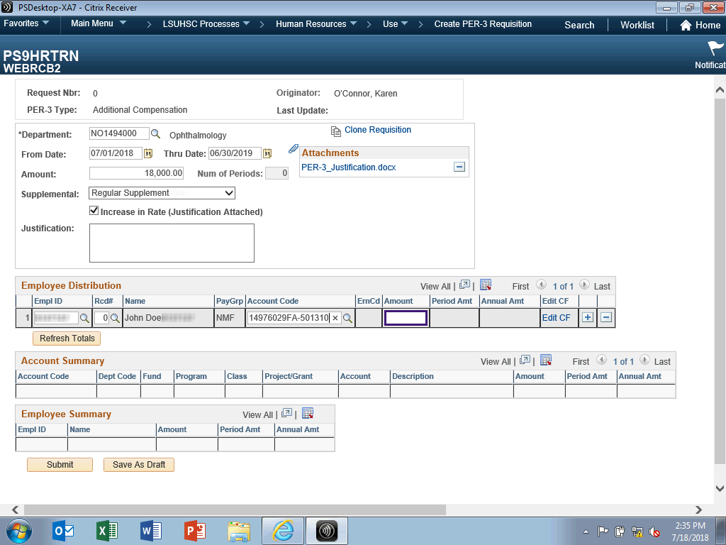

Step | Action
 | Enter the desired information into the Amount field. Enter "18000.00".

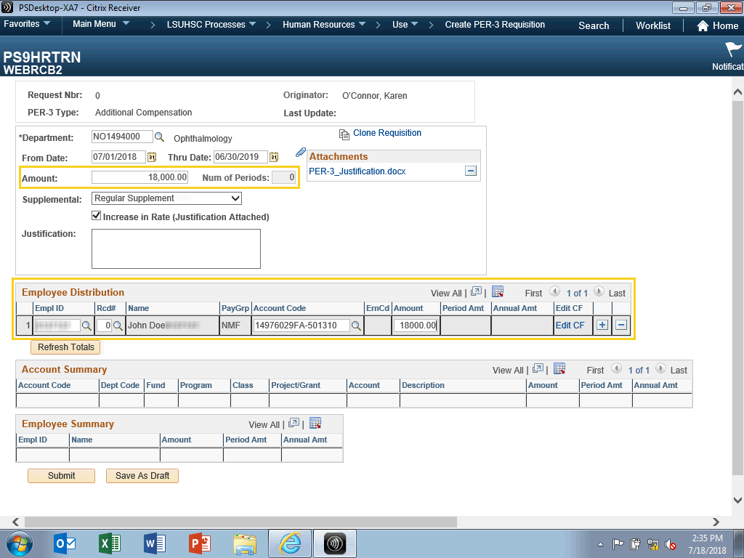

Step | Action
 | Validation will occur between the Amount entered and the amounts entered in the Employee Distribution Section. If there is a mismatch, a warning message will display stating 'Total amount does not equal to calculated distribution amounts'.

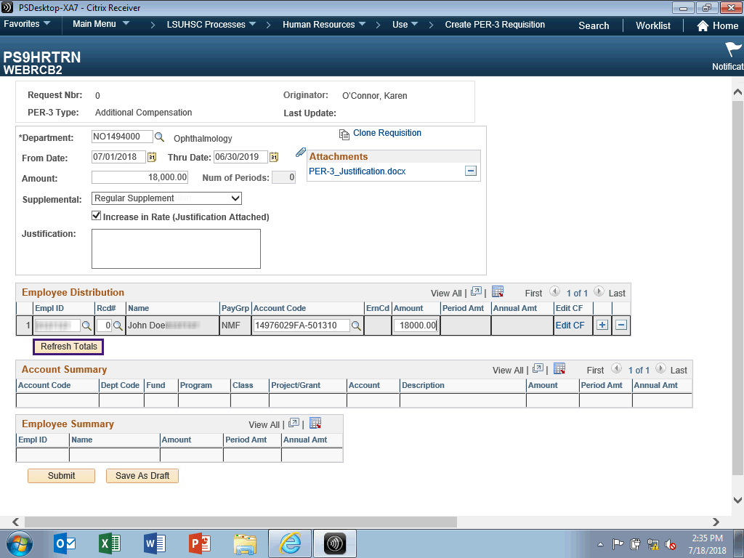

Step | Action
The Refresh Totals button is used to calculate the latest amounts in the account Summary and the Employee Summary sections.

NOTE: You must click the Refresh Totals button if any edits are made on the PER-3 requisition page.

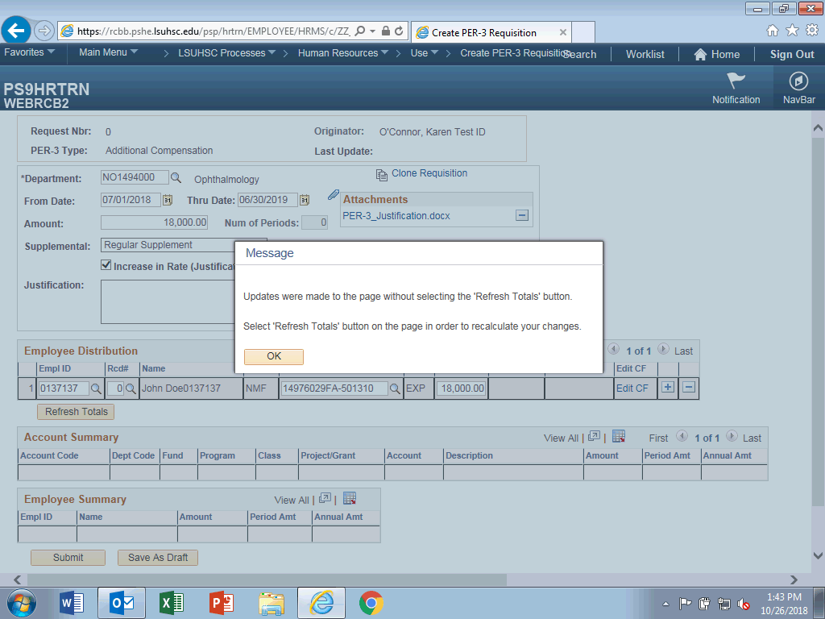

Step | Action
NOTE: You must click the Refresh Total button before clicking Submit to review the latest totals.

The message below will display if you click Submit prior to Refresh Totals.

Step | Action
 | Click the Refresh Totals button.

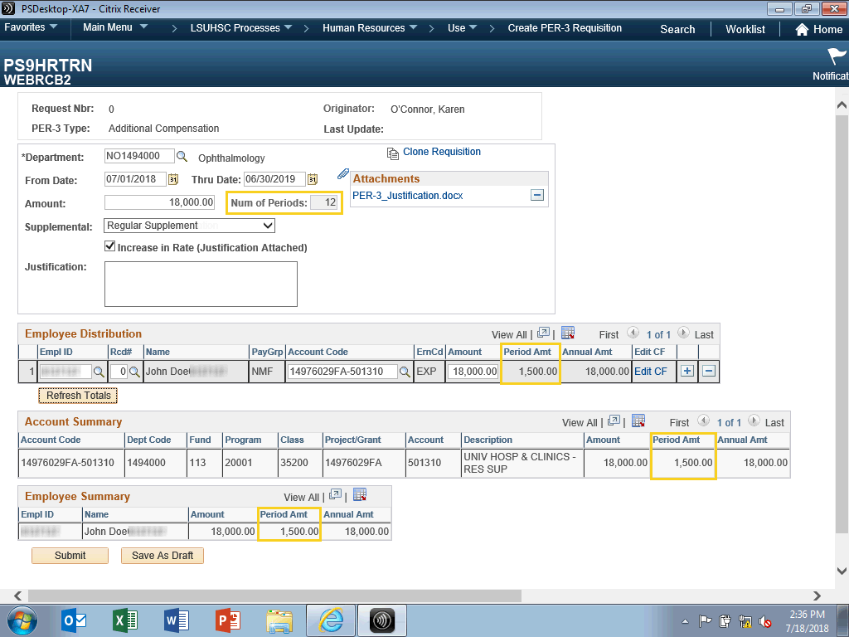

Step | Action
 | The Num of Periods displays as well as the Period Amt.

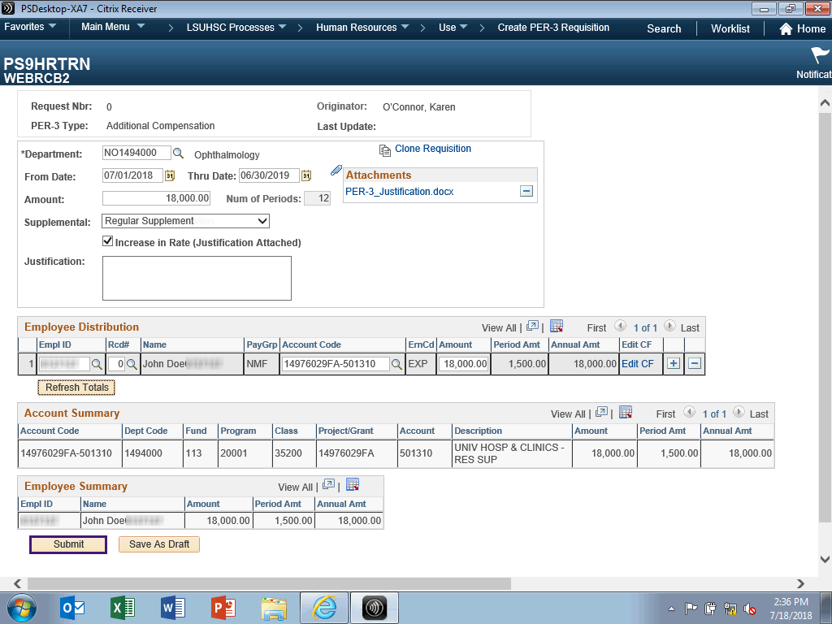

Step | Action
 | Click the Submit button.

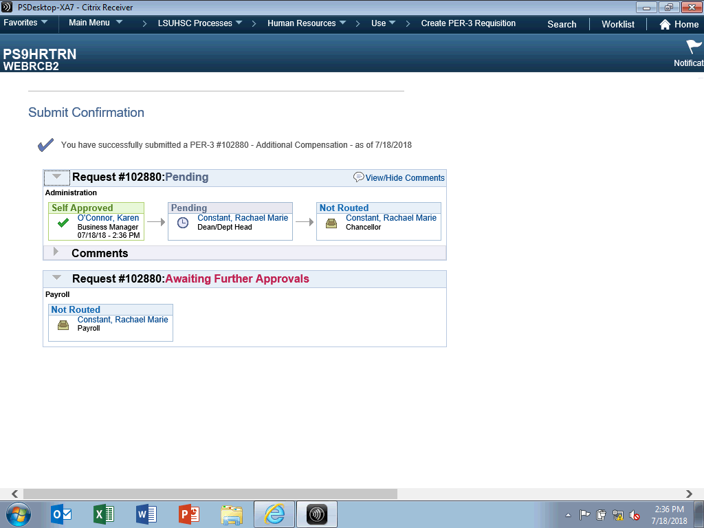

Step | Action
 | Upon successful submission, you will receive a confirmation page showing the approval routings.
This completes Enter a PER-3 Requisition.
End of Procedure.

Clone a PER-3 Requisition
Procedure

In this topic you will learn how to Clone a PER-3 Requisition.

Step | Action
Navigation for creating a PER-3 Requisition displays as breadcrumbs at the top of the page.

Main Menu > LSUHSC Processes > Human Resources > Use > Create PER-3 Requisition

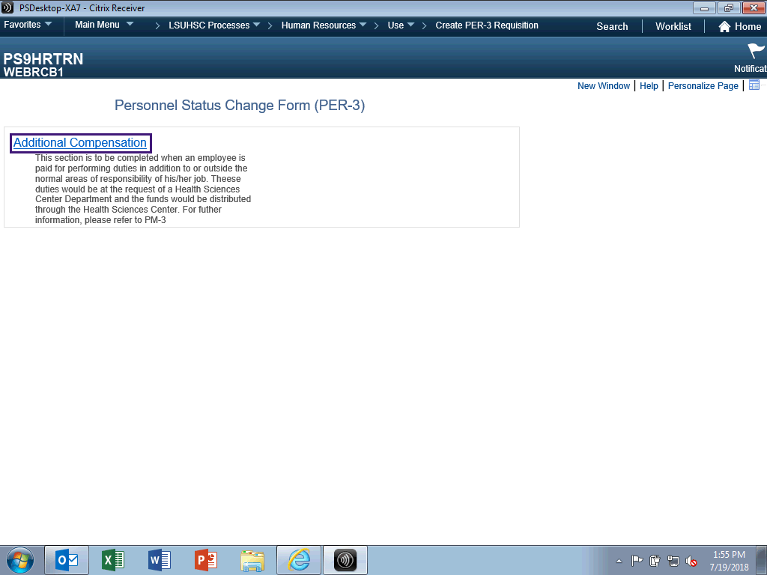

Step | Action
 | Click the Additional Compensation link.

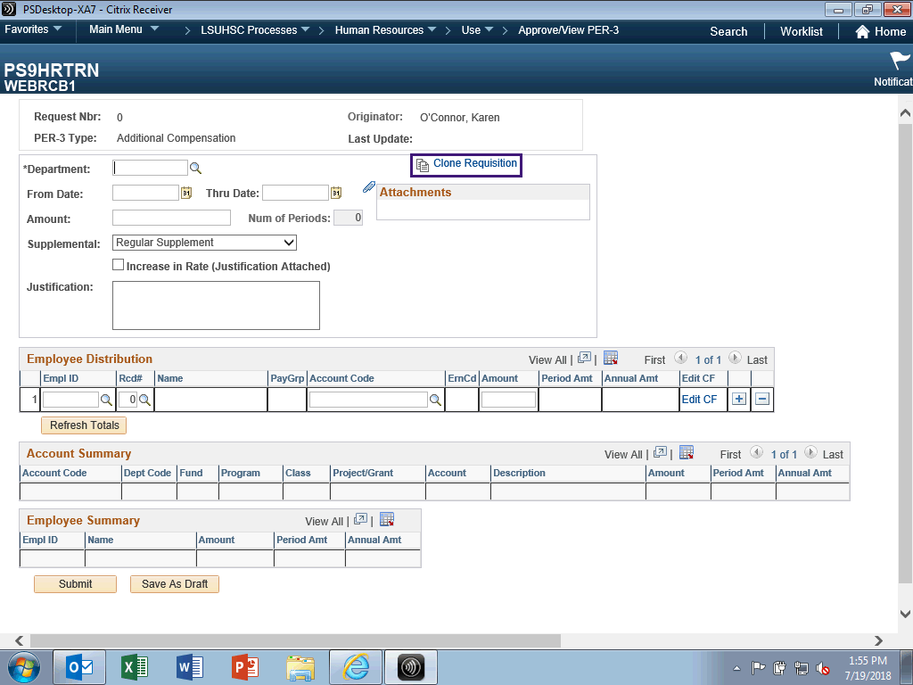

Step | Action
 | Click the Clone Requisition link.

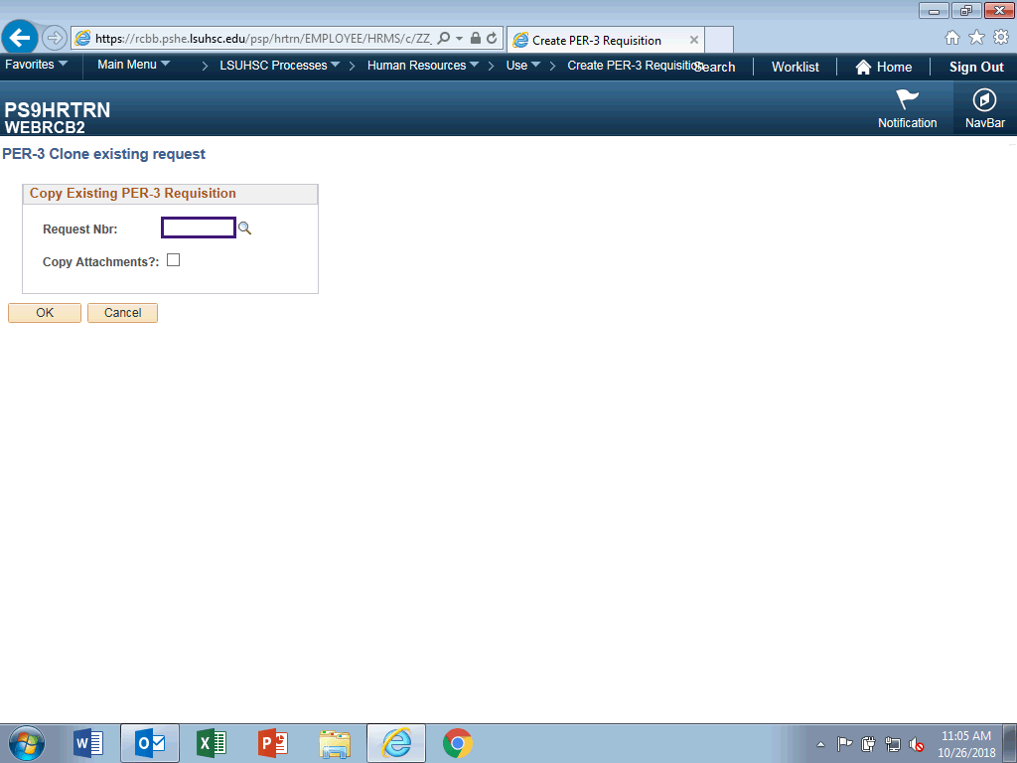

Step | Action
 | Enter the desired information into the Request Nbr field. Enter "103315".
 | Click the OK button.

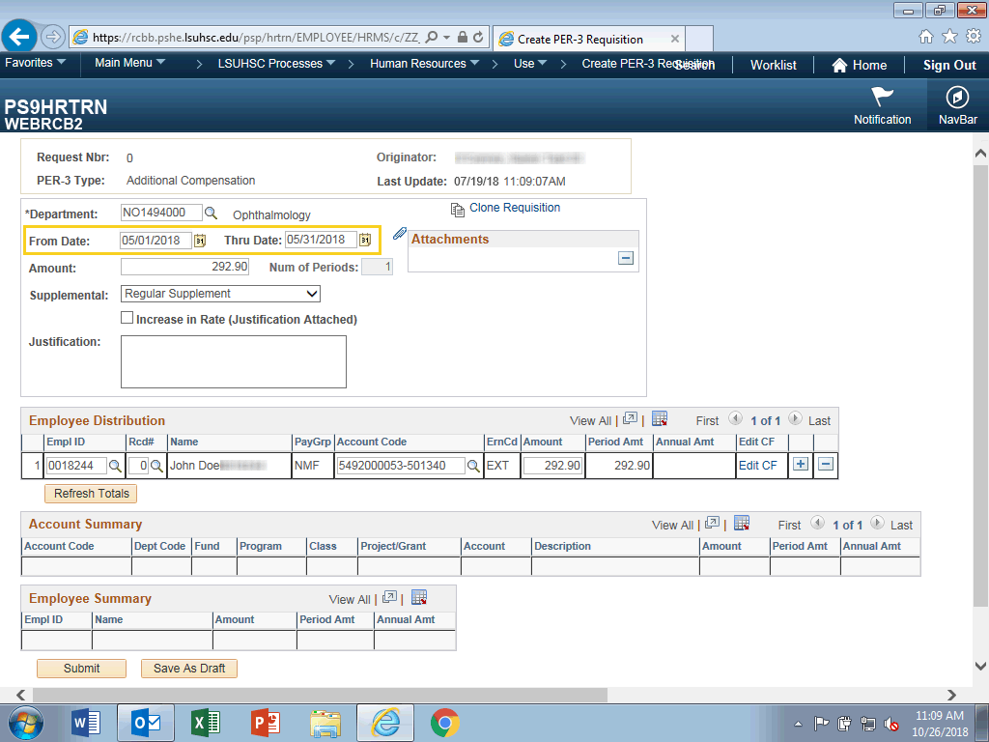

Step | Action
From and Thru Dates

• From Date cannot be older than 180 days (~ 6 months) from today.
• Thru Date cannot be later than 365 days from today.
• From/Thru Dates cannot cross Fiscal Years.

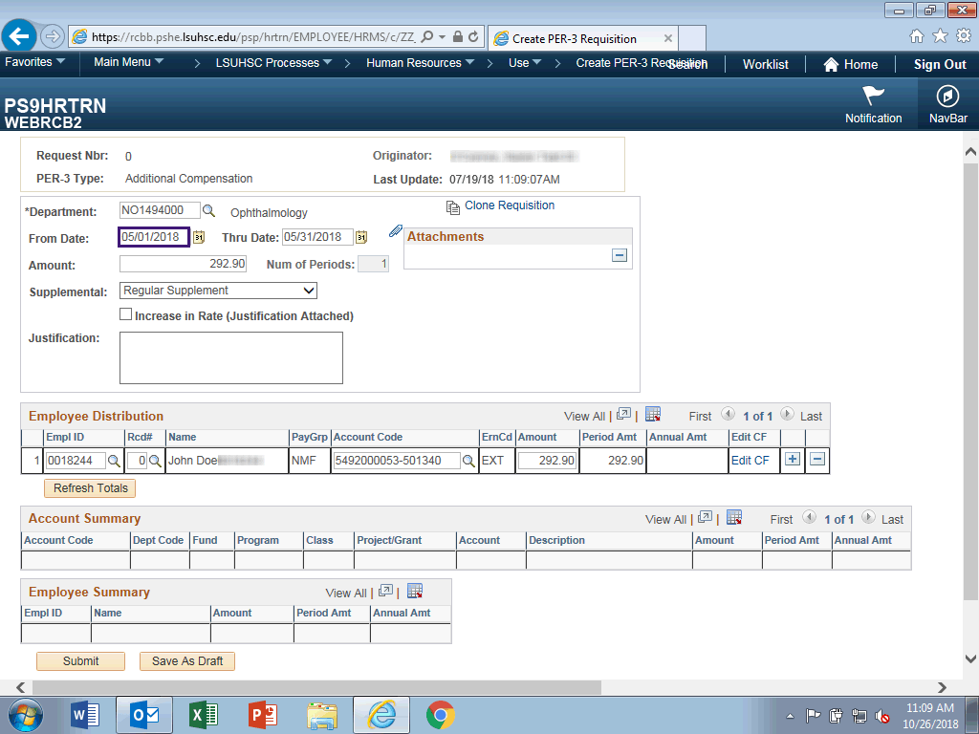

Step | Action
The From Date can only start on the first day of the month.

Enter the desired information into the From Date field. Enter "07012018".

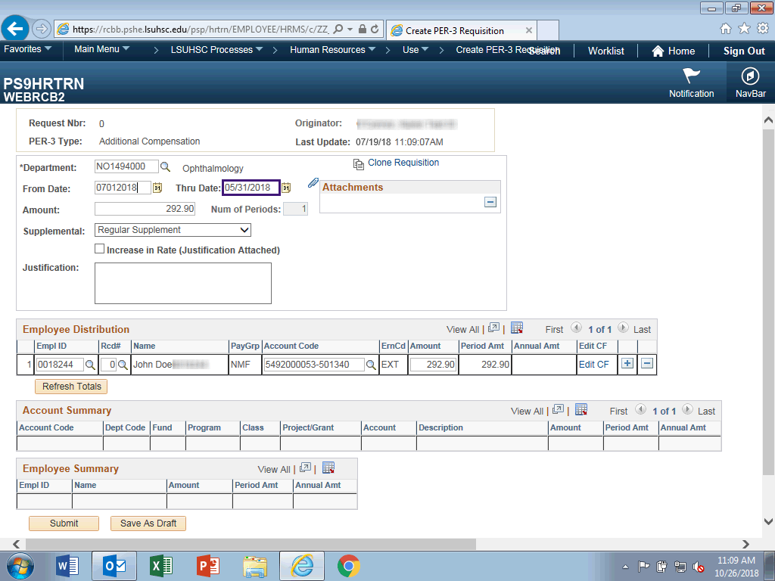

Step | Action
The Thru Date can only end on the last day of the month, unless the period is less than a month.

Enter the desired information into the Thru Date field. Enter "12312018".

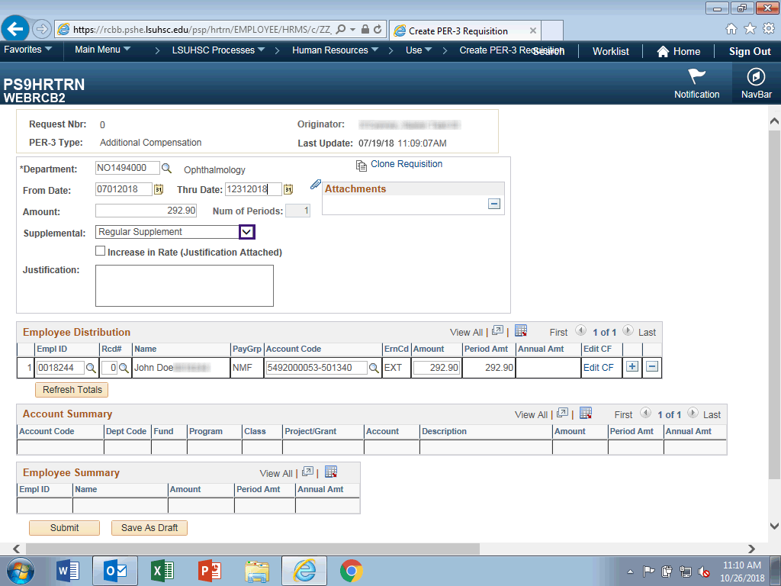

Step | Action
The timeframe is only 6 months, so Supplemental will need to changed from Regular Supplement to Additional Compensation.

Click the button to the right of the Supplemental field.
 | Click the Additional Compensation list item.

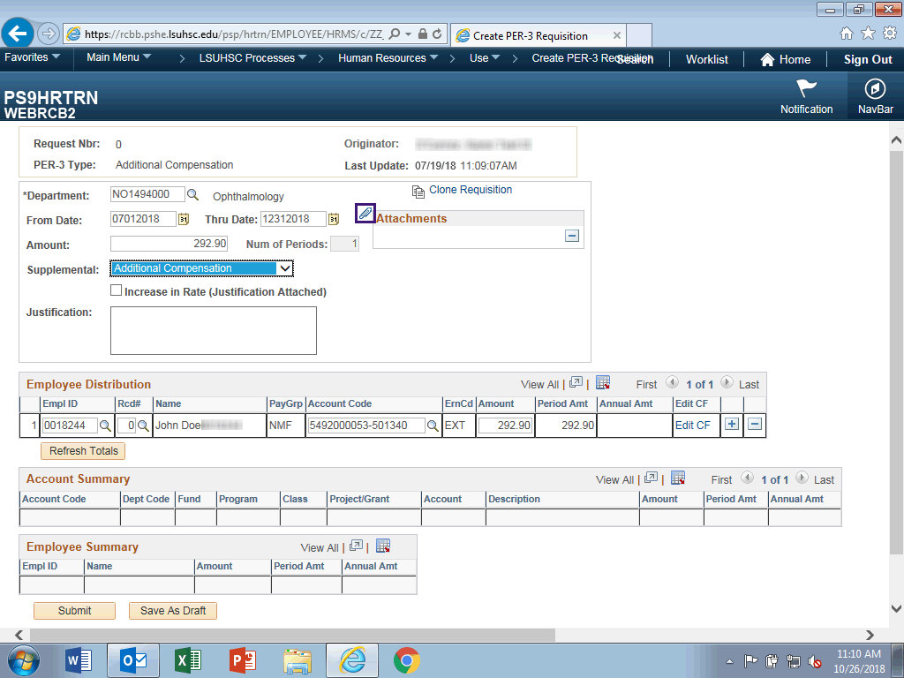

Step | Action
Click the Add Attachment button.

NOTE: Social Security Numbers should not be included in attachments.

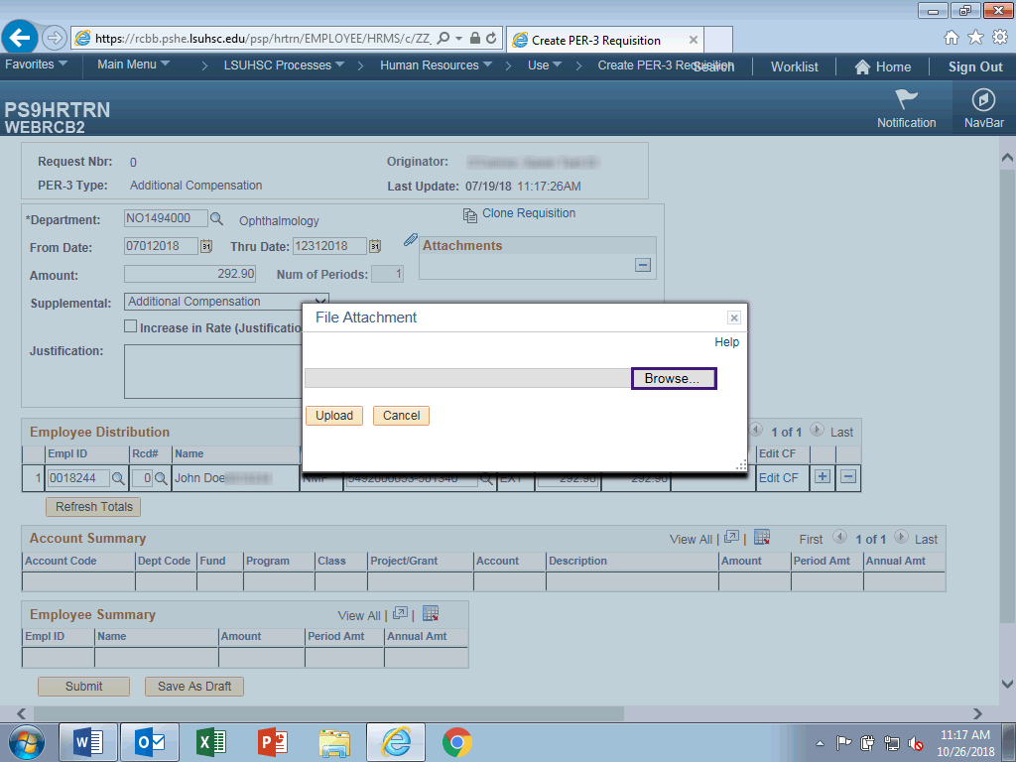

Step | Action
 | Click the Browse button.
 | Click the PER-3 Justification list item.
 | Click the Open button.
 | Click the Upload button.

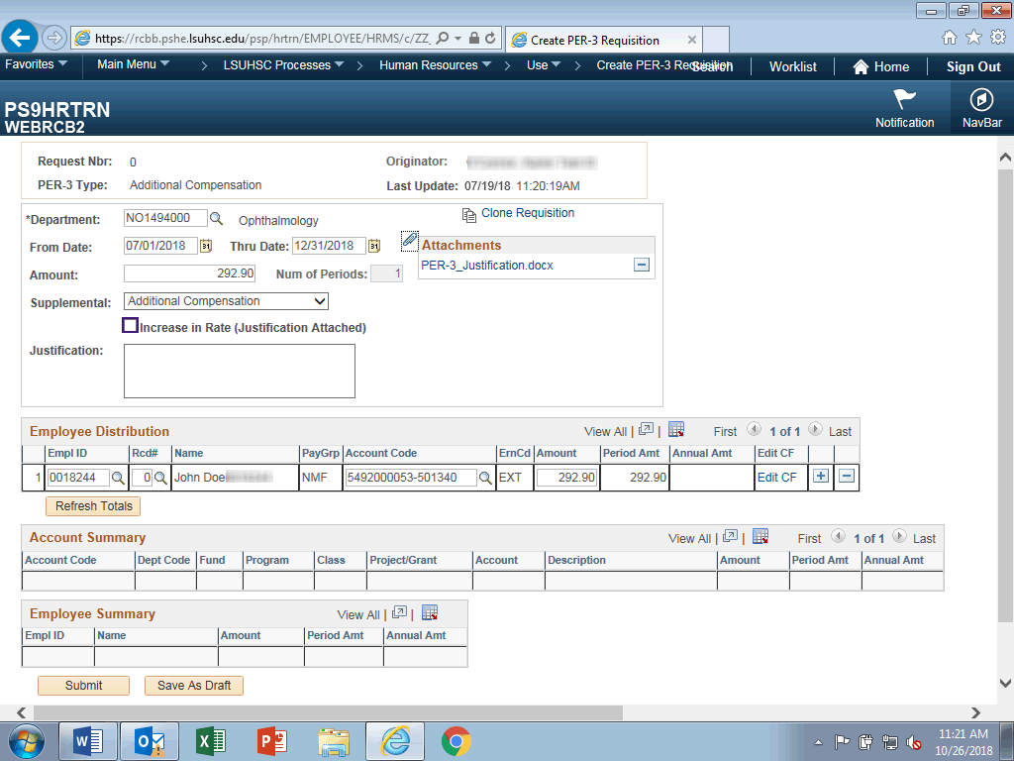

Step | Action
When doing an increase in rate, you must include in your justification when the rate increase will be used (i.e., regular supplement or additional compensation) and why the increase is merited.

Click the Increase in Rate (Justification Attached) option.

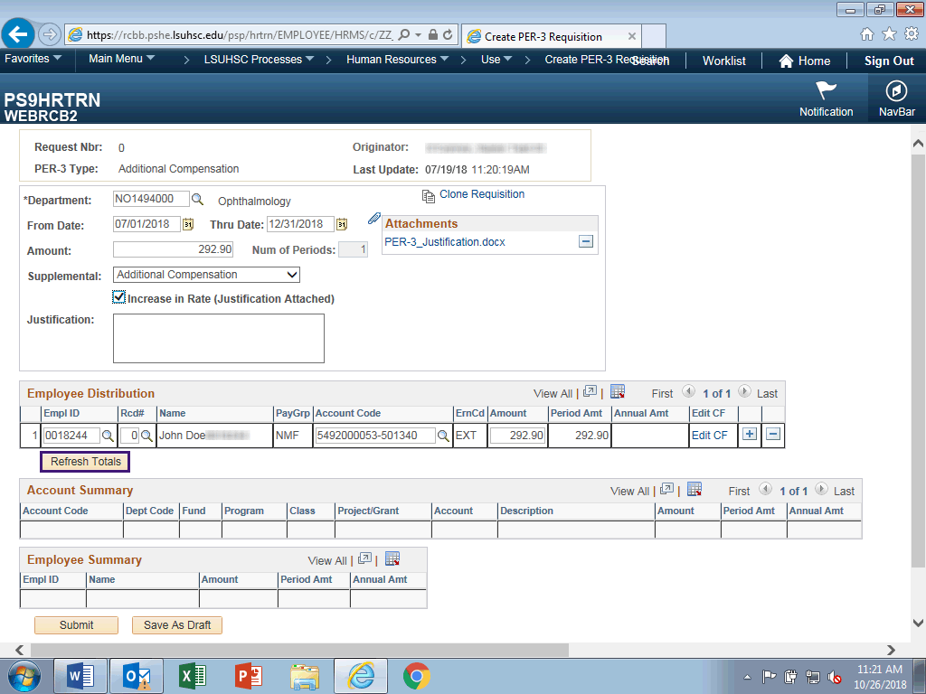

Step | Action
 | Click the Refresh Totals button.

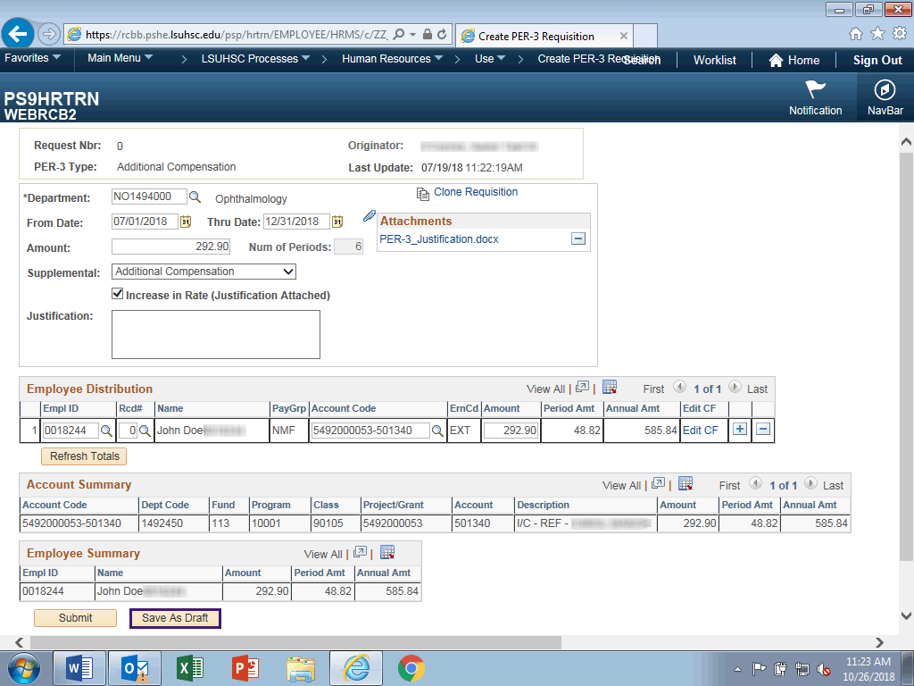

Step | Action
 | Click the Save as Draft button.
This completes Clone a PER-3 Requisition.
End of Procedure.

Review a Saved Draft
Procedure

In this topic you will learn how to Review a Saved Draft.

Step | Action
 | Click the Main Menu link.

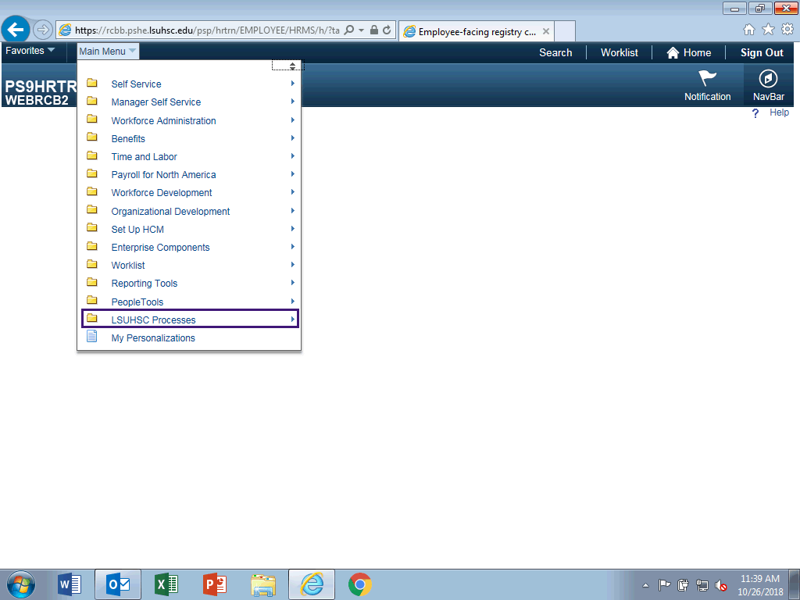

Step | Action
 | Click the LSUHSC Processes menu.
 | Click the Human Resources menu.
 | Click the Use menu.

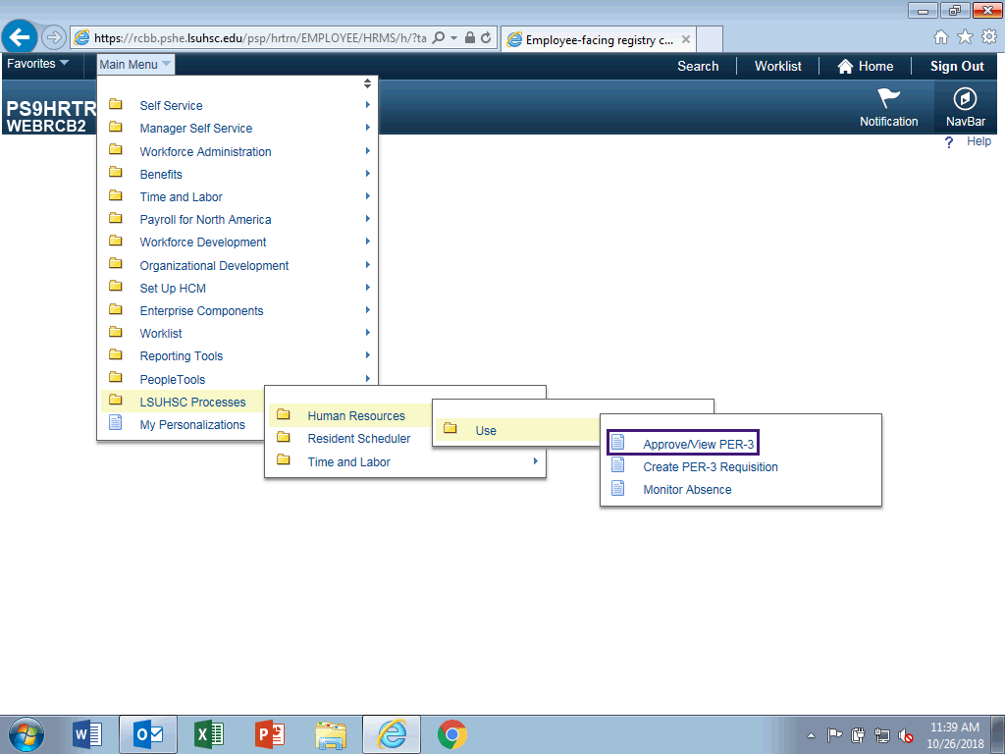

Step | Action
 | Click the Approve/View PER-3 link.

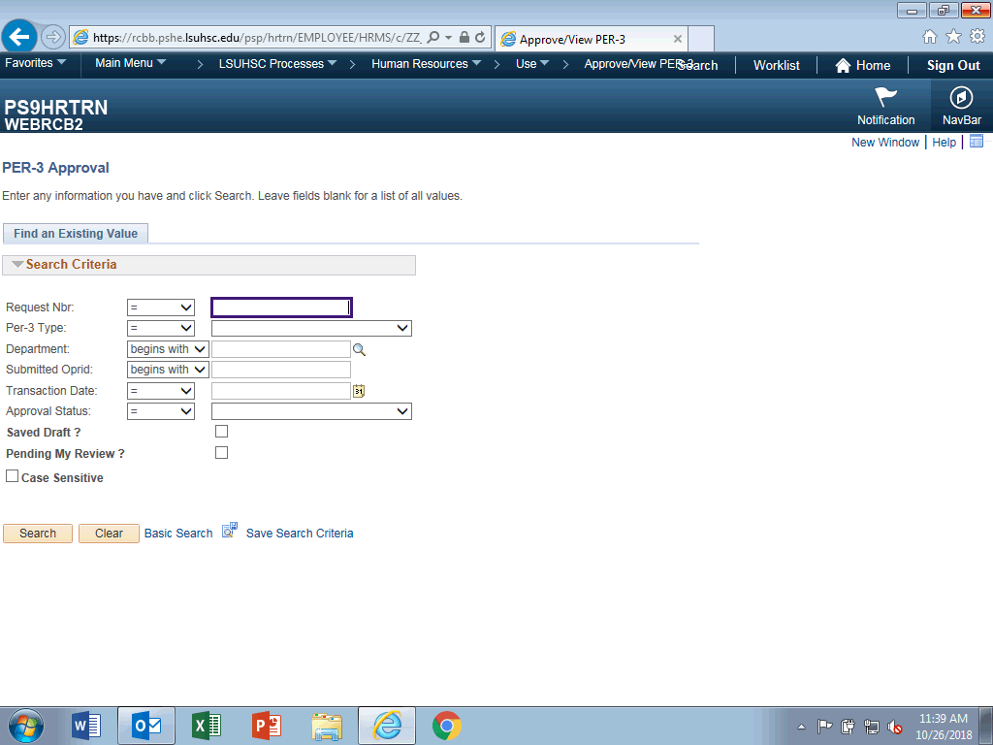

Step | Action
 | Enter the desired information into the Request Nbr field. Enter "103793".

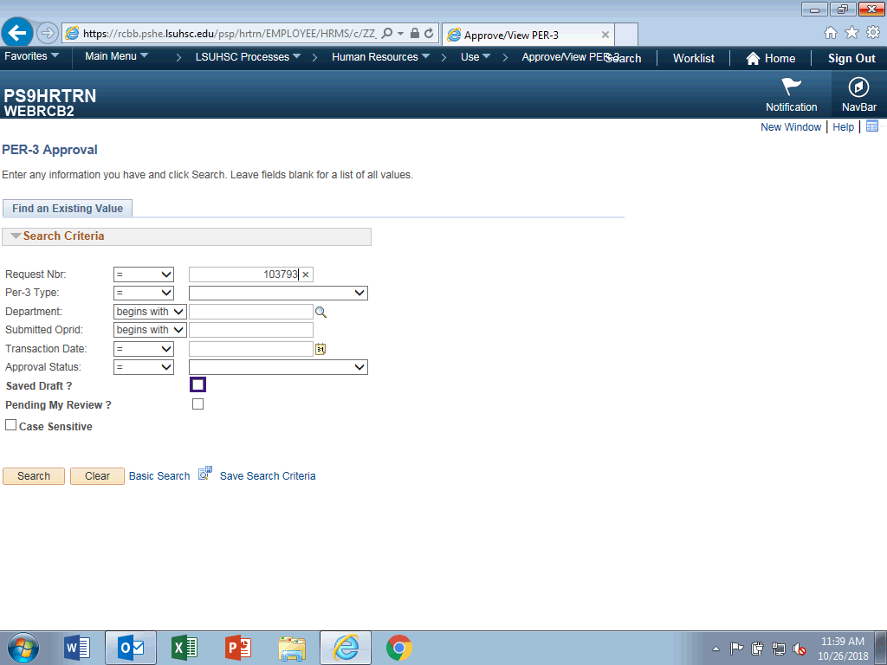

Step | Action
 | Click the Saved Draft? option.
 | Click the Search button.

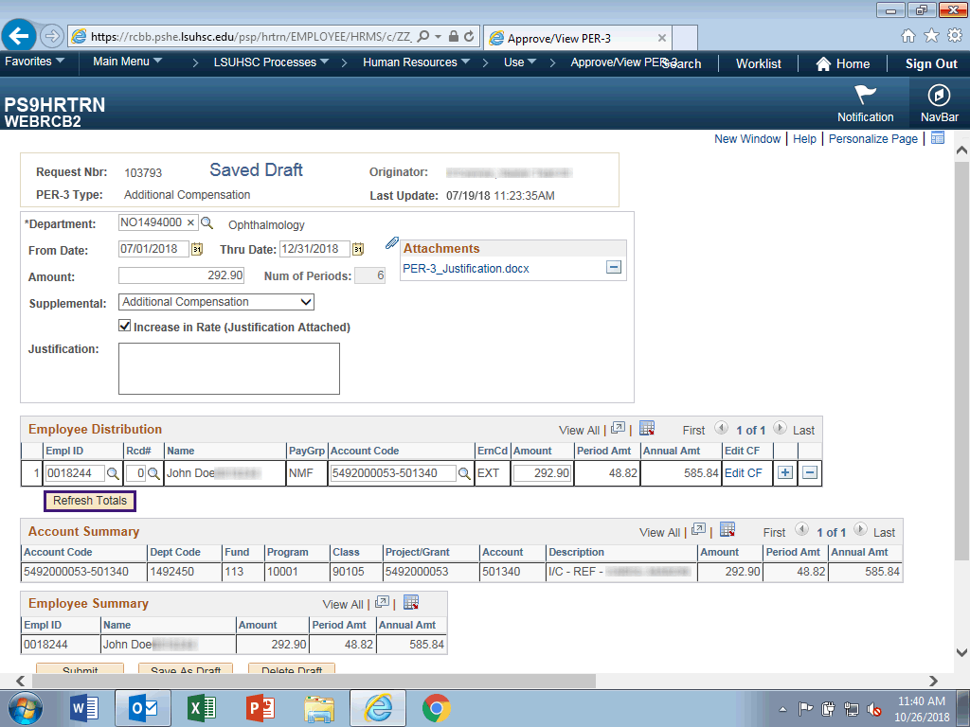

Step | Action
NOTE: Always 'Refresh Totals' before submitting the PER-3 for approval.

Click the Refresh Totals button.

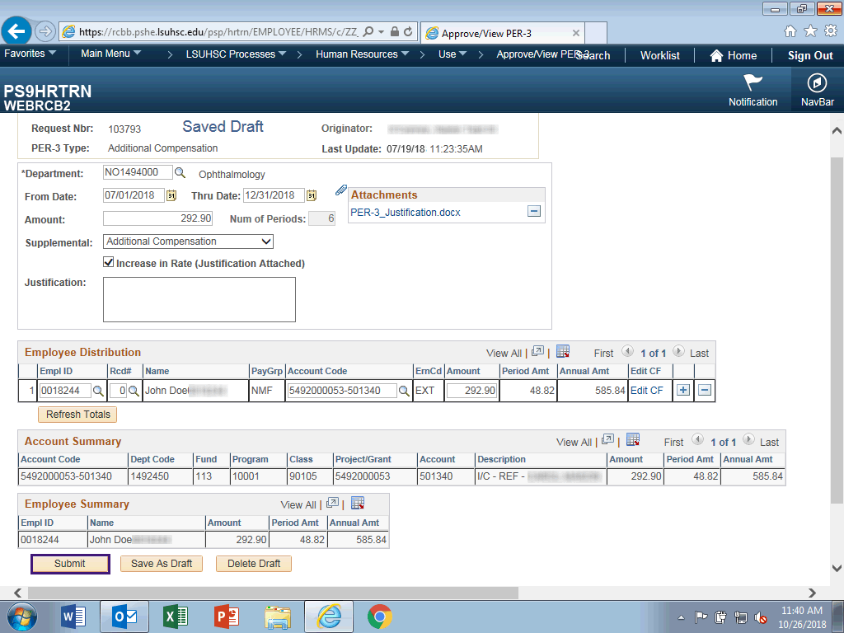

Step | Action
 | Click the Submit button.

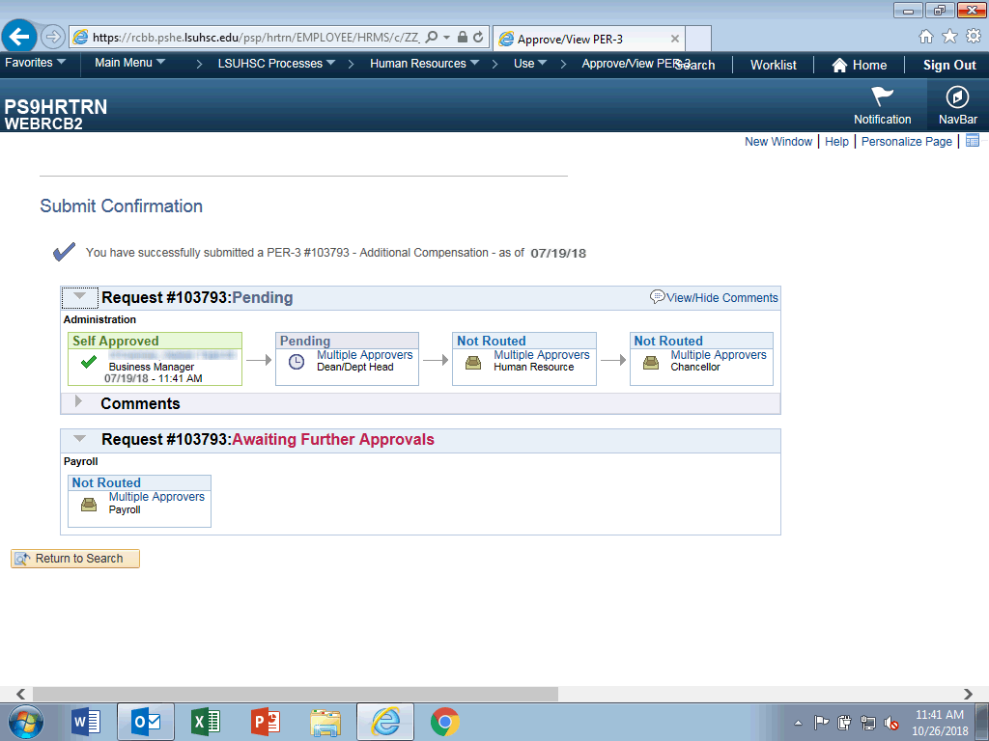

Step | Action
 | Upon successful submission, you will receive this conformation page showing approval routing information.
This completes Review a Saved Draft.
End of Procedure.

